

**DIGITAL MARKETING CA-1**

### Search Engine Optimization

## **Submitted By**

Name : **Pakalapati Satish**

REG : 12210470

Roll No : 50

## **Submitted to**

**Dr Pinnika Syam Yadav**

School of Computer Science and Engineering is a Lovely professional university, in Punjab

**DECLARATION**

This is to certify that I have completed the CA1 of Blogs, Website on one of the interested fields for “Search Engine Optimization(Digital Marketing)-MKT905”, under the guidance of “**Dr. Pinnika Syam Yadav** ”, in the partial fulfillment of the requirement for the award of the degree of B. Tech CSE, Lovely Professional University, Phagwara.

Date:19/03/2025

**Viharayatra Website:**

**[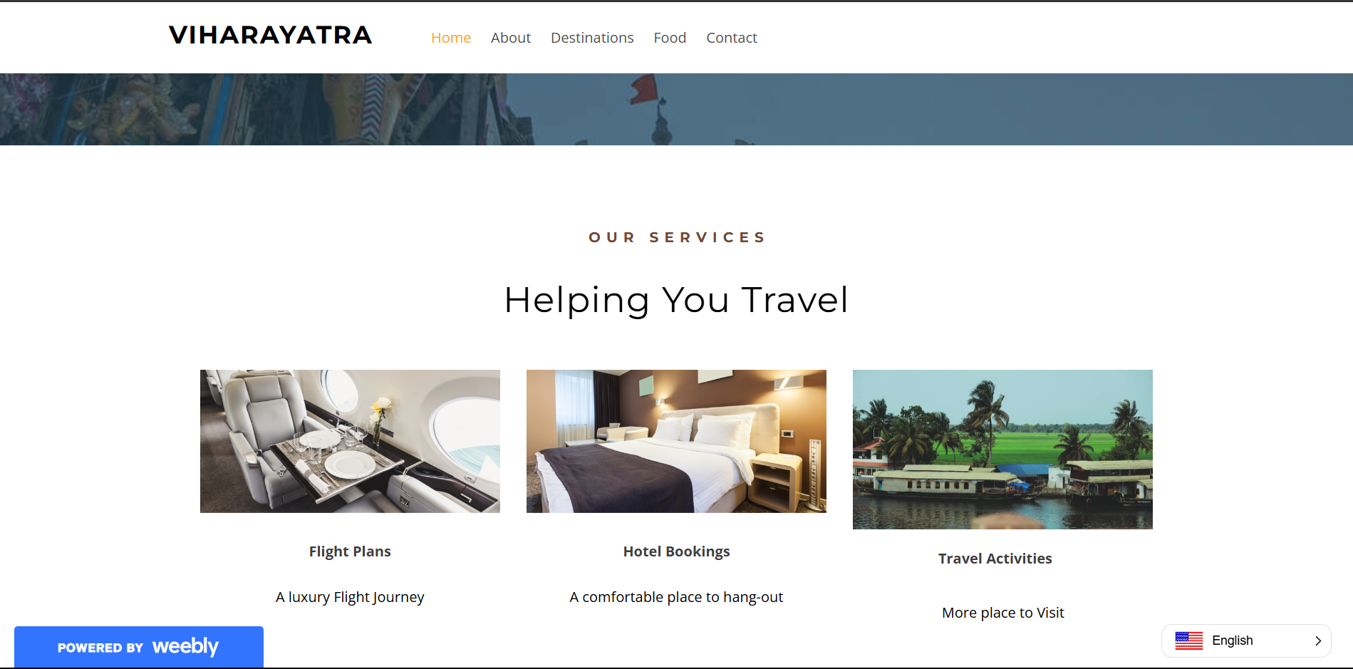](https://viharayatra.weebly.com/)**

Viharayatra Website is a travel guide that helps travelers. VIHARAYATRA_TRAVELS Stand apart from others when you look deeper and deeper, you will find a significant difference. To check the website keenly.

[**click on the pictures/text for the website.**](https://viharayatra.weebly.com/)

**[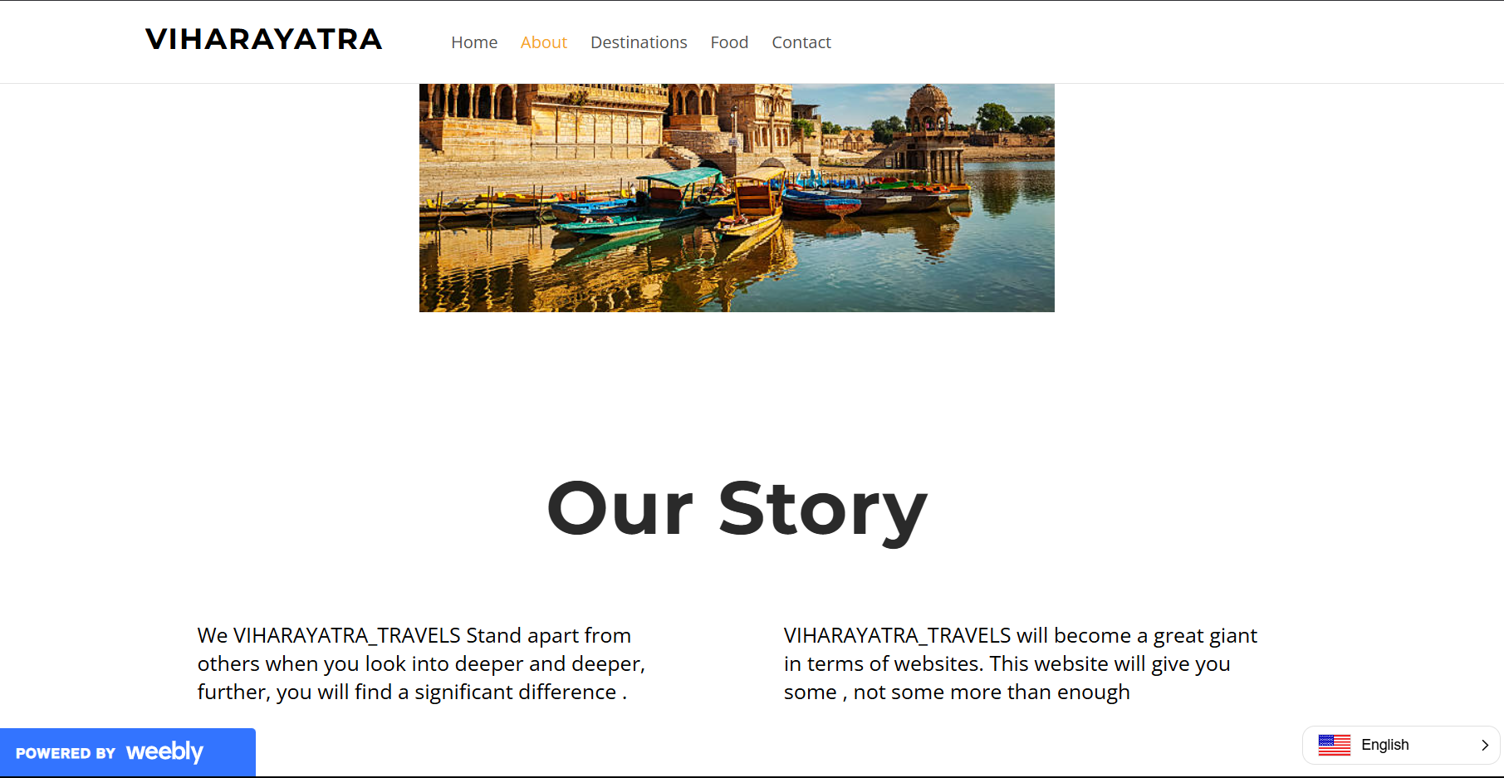](https://viharayatra.weebly.com/about.html)**

**Keyword Research:**

I conducted a keyword research using some websites like SEM Rush, Google Keyword Planner, ubersuggest, backlinko. There I can find keyword difficulty, global volume, CPC, etc…Parameters, Help in deciding the keywords that are needed. All the Keywords and their details are given below.

**Short-Tail KEYWORDS :**

|  |  |  |  |  |  |
| --- | --- | --- | --- | --- | --- |
| sr | KeyWords | K.D % | Volume | CPC $ | Results |
| 1 | Tirupati Temple | 30 | 1.3K | 0 | 21.4M |
| 2 | [amaravati stupa](https://www.semrush.com/analytics/keywordoverview/?q=amaravati%20stupa&db=us&utm_source=backlinko.com&utm_medium=referral&utm_campaign=free-keyword-tool) | 32 | 90 | 0 | 542K |
| 3 | Taj Mahal visit | 46 | 1.6K | 0.35 | 540K |
| 4 | Mysore Palace | 67 | 563.3K | 0.12 | 15K |
| 5 | Hampi ruins | 35 | 1.4K | 0 | 18K |
| 6 | Vijayawada | 55 | 74K | 0.50 | 1.02M |
| 7 | Gandikota | 66 | 35K | 0.30 | 7.20K |
| 8 | Vijayawada temples | 45 | 25K | 0.20 | 8.5k |
| 9 | Kanipakam | 30 | 10.2K | 0.05 | 4.02k |
| 10 | Ahobilam | 50 | 30K | 0.25 | 3.01K |

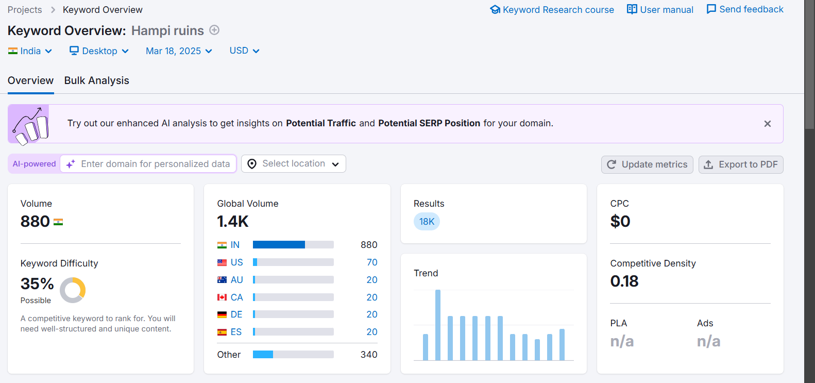

Keyword research

**Long-Tail KEYWORDS :**

|  |  |  |  |  |  |
| --- | --- | --- | --- | --- | --- |
| sr | KeyWords | K.D % | Volume | CPC $ | Results |
| 1 | [tirupati balaji temple place](https://www.semrush.com/analytics/keywordoverview/?q=tirupati%20balaji%20temple%20place&db=us&utm_source=backlinko.com&utm_medium=referral&utm_campaign=free-keyword-tool) | 30 | 720 | 0 | 7.9M |
| 2 | UNESCO sites in Andhra Pradesh | 28 | 1.06K | 0.05 | 0.81M |
| 3 | why is hampi called the city of ruins | n/a | 40 | 0 | 190 |
| 4 | hotels near Mysore palace | 36 | 15.5K | 0.19 | 580 |
| 5 | Best pilgrimage sites in Andhra Pradesh | 50 | 12.01K | 0.40 | 3.05M |
| 6 | Temples in Andhra Pradesh with rich history | 40 | 8.02K | 0.30 | 2.01M |
| 7 | Top historical monuments in Andhra Pradesh | 32 | 4.08K | 0.10 | 1.2M |
| 8 | how to visit taj mahal | 38 | 460 | 0.24 | 40.2K |
| 9 | Historical monuments to visit in Andhra Pradesh | 35 | 1.01K | 0.20 | 120K |
| 10 | Unexplored historical places in Andhra Pradesh | 42 | 0.54K | 0.28 | 50K |

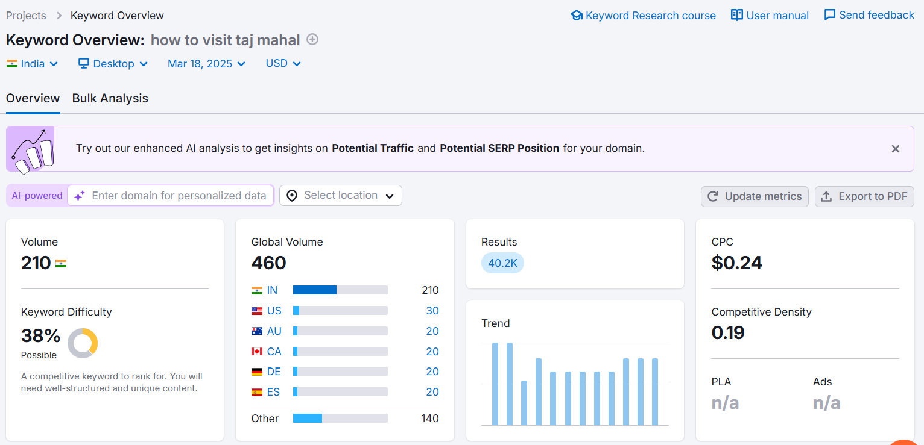

Long Tail keyword research

,

**Selecting Suitable Keywords for Website:**

|  |  |  |  |
| --- | --- | --- | --- |
| 30% | 1.3K | 0 | 21.4M |

Tirupati Temple:

KD Volume CPC Results

|  |  |  |  |
| --- | --- | --- | --- |
| 35% | 1.4K | 0 | 18K |

Hampi ruins:

Gandikota:

|  |  |  |  |
| --- | --- | --- | --- |
| 56% | 35K | 0.30 | 7.20K |

|  |  |  |  |
| --- | --- | --- | --- |
| 55% | 74K | 0.50 | 1.02M |

Vijayawada:

|  |  |  |  |
| --- | --- | --- | --- |
| 46% | 1.6K | 0.35 | 540K |

Taj Mahal Visit:

|  |  |  |  |
| --- | --- | --- | --- |
| 32% | 4.08K | 0.10 | 1.2M |

Top historical monuments in Andhra Pradesh:

|  |  |  |  |
| --- | --- | --- | --- |
| 40% | 8.02K | 0.30 | 2.01M |

Temples in Andhra Pradesh with rich history:

|  |  |  |  |
| --- | --- | --- | --- |
| 42% | 0.54K | 0.28 | 50K |

Unexplored historical places in Andhra Pradesh:

|  |  |  |  |
| --- | --- | --- | --- |
| n/a | 40 | 0 | 190 |

why is hampi called the city of ruins:

|  |  |  |  |
| --- | --- | --- | --- |
| 30% | 720 | 0 | 7.9M |

[tirupati balaji temple place](https://www.semrush.com/analytics/keywordoverview/?q=tirupati%20balaji%20temple%20place&db=us&utm_source=backlinko.com&utm_medium=referral&utm_campaign=free-keyword-tool):

**Inconsideration of these parameters of keywords, There have been identified as suitable for website.**

**Linking To Website:**

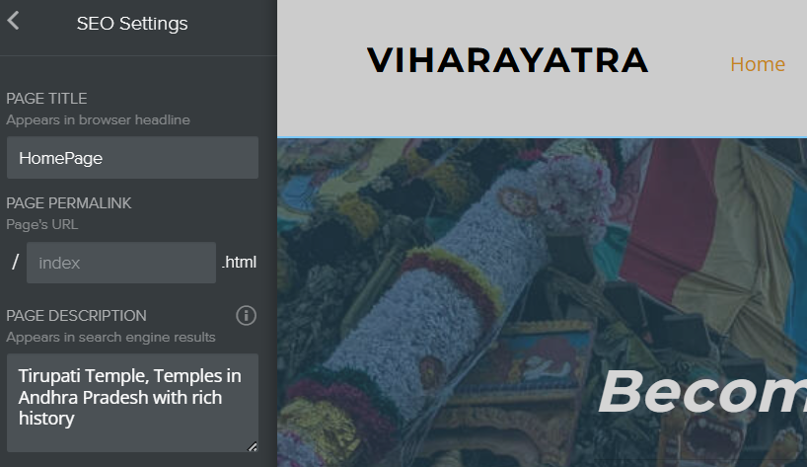

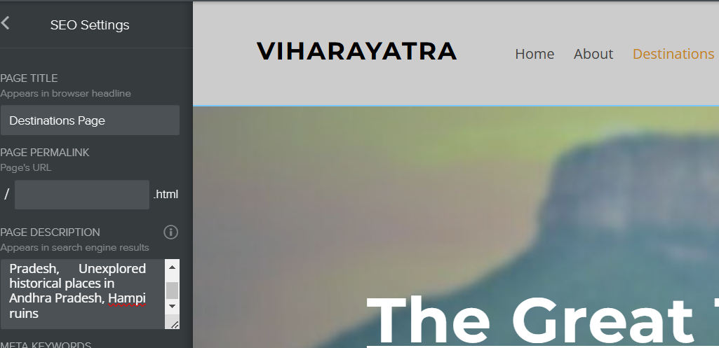

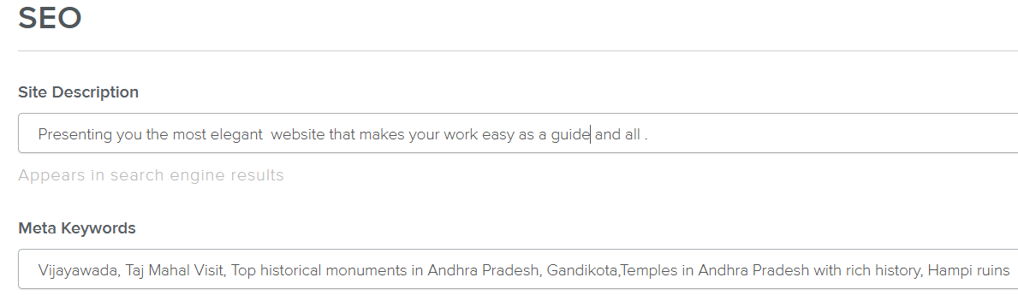

Adding keywords to web pages

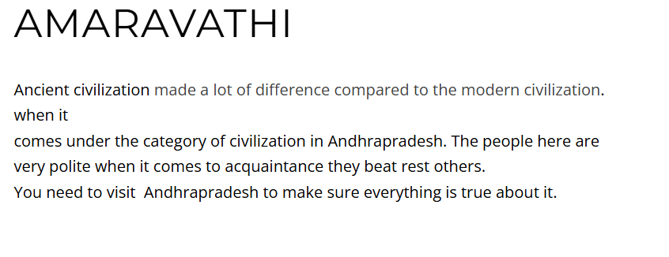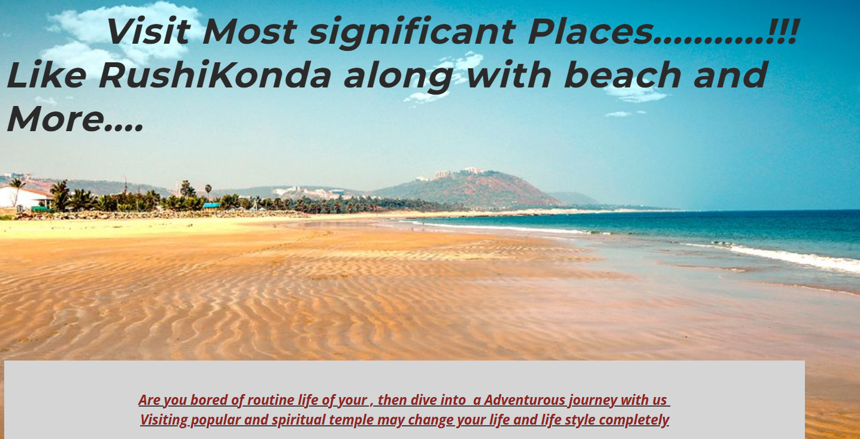

**Successfully added Keywords to our website on page and off page……>**

**Off Page Optimization:**

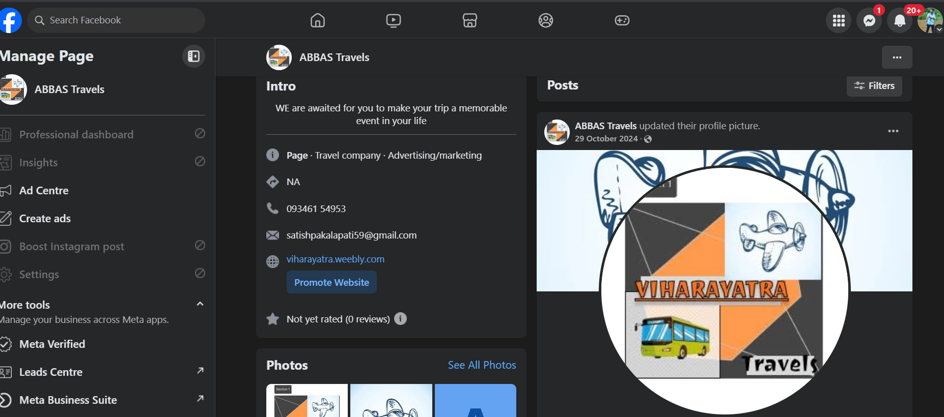



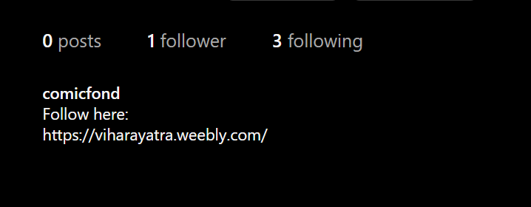



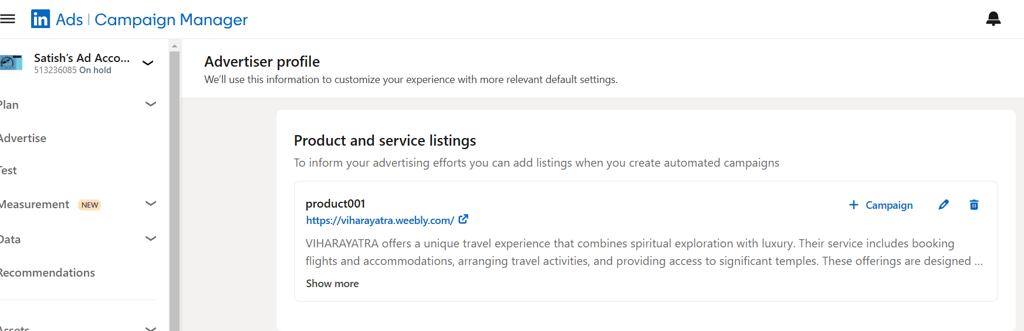

**Successfully added backlinks to social media platforms for optimization.**

**Next Step is to add some blogs in associate to our website.**



**Blog done…**

**Internal Links From Website with buttons/pictures:**

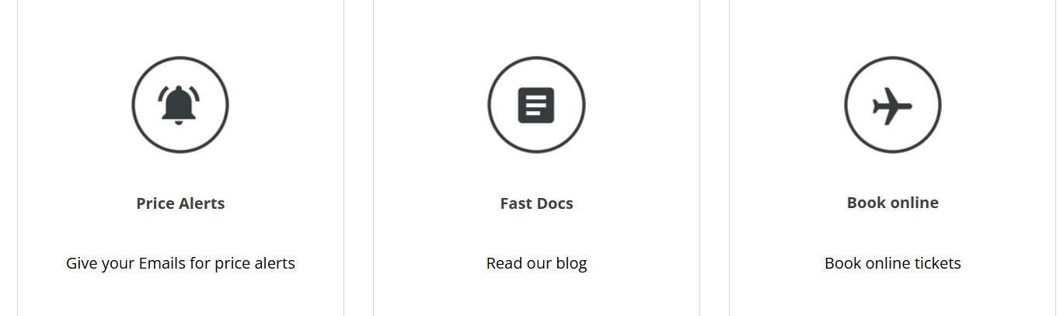



These Pictures and Buttons will redirect, users to explore websites seamlessly.

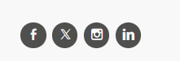



**Off-Page Optimization is done for website…**

**Site Analytics :**

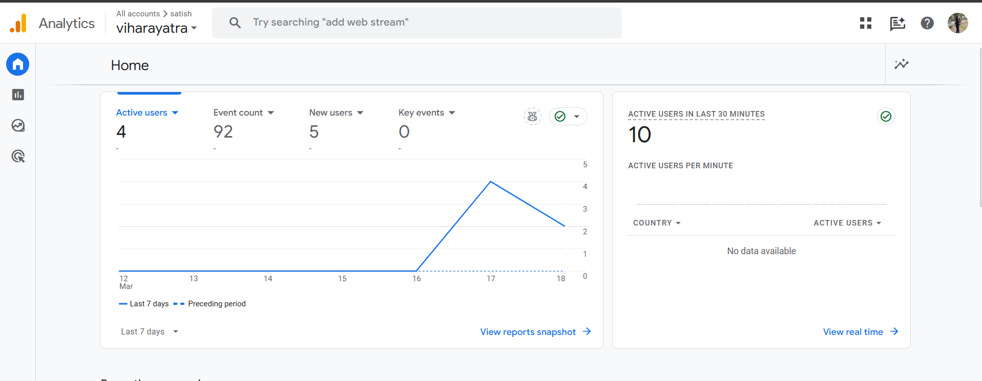

**Analytics Interpretation :**

* The website demonstrates extremely low engagement because of its four active users during seven days although the registration process was active.
* This data points to possible problems with both user journey optimization and call-to-action strategies because no essential user interactions were tracked.
* A quick check must be made to determine the reason for the atypical traffic jump of ten active users since the last 30 minutes.

**Conversion Rate:**

* Keyword Research
* Content Optimization
* Backlink Building

**By implementing effective SEO strategies, the website can attract more qualified traffic, leading to increased active users and potentially higher conversion rates.**

**SEO Web Design and Mobile Optimization :**

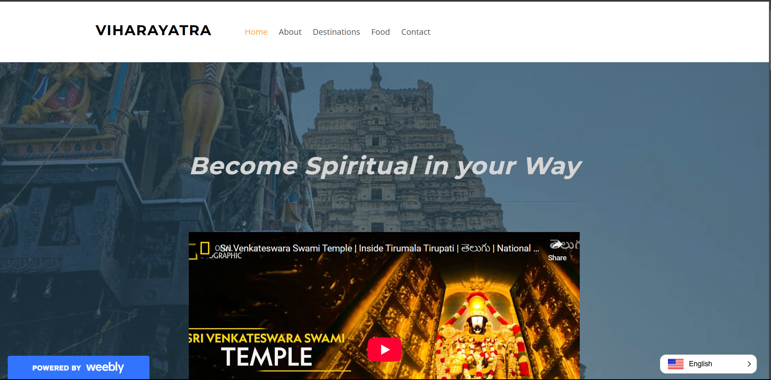

**Desktop Web Page**

**d**

* Designing an SEO-friendly website structure and layout.
* Ensuring mobile-friendliness and responsiveness for optimal user experience.
* Implementation of SEO best practices to improve website search engine compatibility.

**Mobile Web Page**

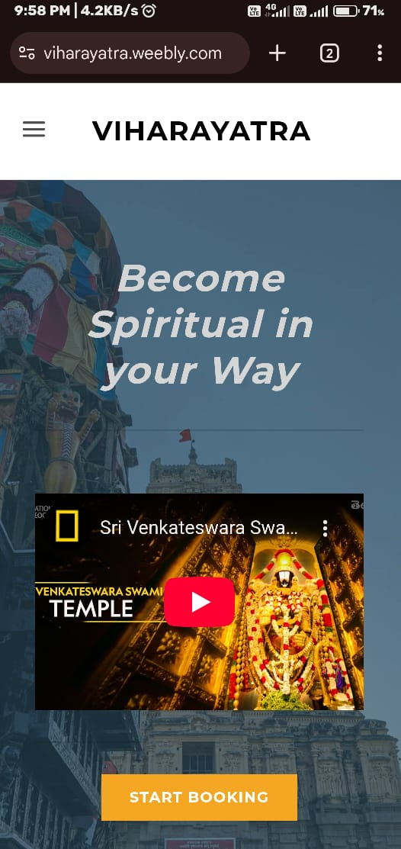

**Conclusion:**

This Digital Marketing Assessment consists of Keyword research, Analytics, Off-Page Optimization, SEO Web Design and Mobile Optimization and other things mentioned as per the Guidelines… **- CA 1**